A Virtual Tour to London
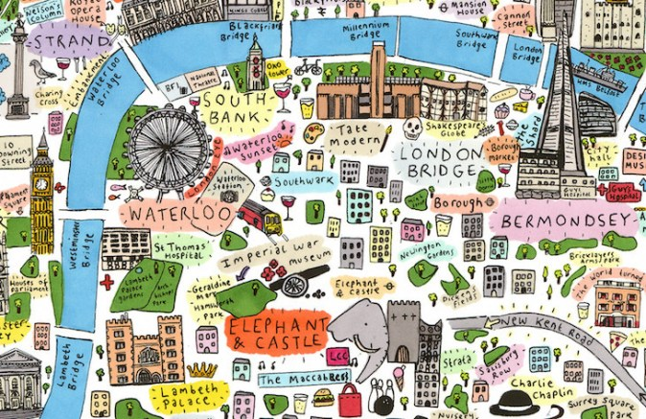
- Write down all the sights that have been mentioned in the video

- What’s it?
The most comfortable way to travel around London
A giant Ferris wheel on the South Bank of the River Thames
the Great Bell of the clock inside Elisabeth Tower
The building where the House of Commons and the House of Lords are situated
London King’s Cross is located there
Walking along this path you can find a lot of museums
London’s Times Square
You find The Crown of Jewels there
You can eat the most traditional fish and chips there

- Answer the questions
- What’s the name of London’s most popular travelling card?
- How type of buses is typical of London?
- What two London’s sights are ideal for nature lovers?
- Which station is London Eye at? Why has it been constructed?
- What’s the Buckingham Palace famed for?
- What are the royal guards called?
- Where does Birdcage Walk lead to? Why did it get its name?
- Which station can you find Platform 9 ¾ at?
- Where is the Tower of London situated in?
- What’s the name of the monument dedicated to the people defending peace during war?

